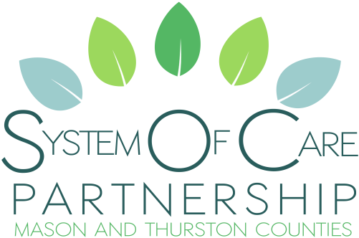
b
Vision: We are a community working together to strengthen sustainable resources for the individual behavioral health needs of children, youth and families.
Mission: Through respectful partnerships, families, systems and communities collaborate, influence and provide leadership to address challenges and barriers by promoting cohesive behavioral health services for children, youth and families.

Friday May 26th from 10 am until Noon

Zoom Link: https://us02web.zoom.us/j/5857207072
Call In: 1-253-215-8782 Meeting ID: 585 720 7072

AGENDA
Welcome (18)
- Zoom Tools/Information
- Introductions
- Reading of Vision & Mission
- Comfort Agreement
- Tri-lead Listening Statement
Today’s Goals (2)
- Area of Focus
  - Workgroup Update
- Wise Data Presentations
  - Community Youth Services
  - Catholic Community Services
- Tri-lead Positions Update
  - Family and Youth
- Meetings
  - Meeting Time Change Discussion
- Share Time

Area of Focus – More Mental Health Awareness in Schools (25)
- Workgroup Update
- Questions/Comments
Wise Presentations (20)
- Community Youth Services
- Catholic Community Services
Tri-lead Positions Update (15)
- Family Tri-lead Statement
  - Continue Survey Vote
- Youth Tri-lead Statement
  - Poll
Meetings (20)
- Meeting Time Change Discussion
Share Time (15)

- Questions or comments about today’s goals/agenda.
- General Sharing
- Information/Announcements
- New or Existing Program Updates
- Additional Questions/Comments

Adjourn

This is the list of goals and chosen strategies related to our area of focus, which is about more mental health awareness and fluency taught in schools, to parents and to staff.
Goal A
A. Opportunities for youth to volunteer with other kids to help – everyone learns and this provides mentorship opportunities for kids. Matching kids based on strengths and needs – pairing a youth with great ability to manage their energy, for example, with a youth who needs additional skills in this area. Students to be able to mentor students at other schools.
Chosen Strategies
A2. Provide Teen Mental Health First Aid to schools – ESD 113 could potentially provide this, or trainers from other organizations in partnership
A4. Have youth who are interested in being mentors/volunteers write a bio and submit to SOCP and connect them with school counselors - Consider specific mentors for BIPOC students/LGBTQIA+ students, making sure that supports have life experience and understand the populations.

Goal B
B. Mental health initiatives at schools to create/inform around mental health needs – student driven and led (SOCP do the initiative?)
Chosen Strategy
B2. ESD does quarterly mental health campaigns in schools – coordinated through prevention/wellness clubs. Would love to make these available to other schools who don’t have Campaigns for Mental Wellness/Suicide Prevention so they can execute them on their campus. (11 votes)

Goal C
C. Classes do an activity that elicits ideas from students – what can we do better/change? Anonymous notes. Consider providing incentives like gift cards for small amounts.
Chosen Strategy
C3. Look at existing surveys recently done by HCA and Department of Health, look at trends and then make a plan (10 votes)

Contacts for Questions, Comments or Concerns

Tri-lead Information

Jacque Ward, Co-Family Tri-lead
jacqueward72@gmail.com

Dena Wagner, Co-Family Tri-lead
dwagner360@gmail.com
360-338-2239

Lauren Farmer, Co-System Tri-lead
360-704-7170 x 11218

Heidi Knadel, Co-System Tri-lead
Heidikn@ccsww.org
360-791-0785

Convener Contact Information

Donna Obermeyer
360-790-7505
familyalliancewashington@gmail.com
https://www.familyallianceformentalhealth.com/system-of-care-partnership.html

Story Group Resource and Technical Assistance

Carrie Moisey
360-346-0299
carriem@ccsww.org

